# How are sports injuries classified and managed?

## Ways to classify sports injuries

1. A direct injury is located...

1. **at the site of external contact/force**.
2. in bone or teeth.
3. in soft tissue
4. away from the site of external contact.

2. Which of the following is an example of a soft tissue injury?

1. broken arm
2. **torn muscle**
3. tooth falling out
4. dislocated shoulder

3. Classify the injury in the video. <https://youtu.be/eIA73A7H8G4> 52-60 seconds

1. direct soft tissue injury
2. overuse soft tissue injury
3. **indirect soft tissue injury**
4. direct hard tissue injury

4. Classify the injury in the image.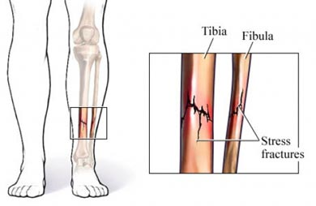

1. stress fracture injury
2. **overuse hard tissue injury**
3. direct hard tissue injury
4. indirect hard tissue injury

5. What kind of injury is in the video? <https://youtu.be/rQdQb-kQ40g> at 17-23 seconds

1. **Direct**
2. Indirect  Overuse

6. An overuse injury is the result of

1. not enough rest
2. small injuries
3. not fully recovering
4. secondary damage to tissue
5. **all of the above**

7. An indirect injury

1. **occurs as a result of internal forces**
2. occurs at the site of external contact/force
3. is a result of a lack of rest
4. such as a bruise

8. Hard tissue injury occur to...

1. **bones and teeth**
2. muscles and bone  l
3. igaments and tendons
4. skin and muscles

9. Soft tissue injury occurs to...

1. bones and teeth
2. muscles and bones
3. **all tissue other than bones and teeth**
4. ligaments, tendons, muscles, skin and bone

10. Classify the injury in the image (at the site where a cricket ball hit him)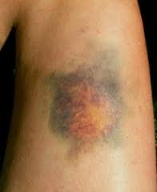

1. direct hard tissue injury
2. **direct soft tissue injury**
3. indirect hard tissue injury
4. overuse soft tissue injury

## Soft tissue injuries

1. Which of the following is NOT a soft tissue injury?

1. tears
2. sprains
3. contusions
4. **fracture**

2. RICER stands for...

1. Rest, Ice, CPR, Elevation, Referral
2. Rest, Ice, Compression, Referral
3. **Rest, Ice, Compression, Elevation, Referral**
4. Rest, Ice, Compression, Excavation, Referral

3. The main actions when treating skin injuries are:

1. **Control bleeding, clean wounds, cover (non-stick dressing)**
2. Control bleeding, clean wounds
3. Control bleeding, cover (non-stick dressing)
4. Control bleeding and infections

4. The 3 stages of the inflammatory response in order are:

1. Acute inflammation, remodeling, repair
2. remodeling, repair, acute inflammation
3. **Acute inflammation, Repair, Remodeling**
4. remodeling, acute inflammation, repair

5. Identify the injury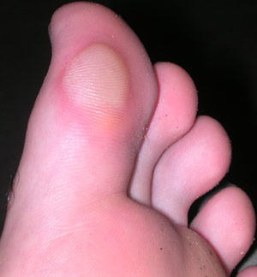

1. **Blister**
2. laceration
3. abrasion
4. contusion

6. Identify the injury 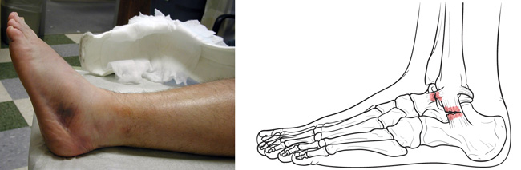

1. Blister
2. contusion
3. abrasion
4. **sprain**

7. Identify the injury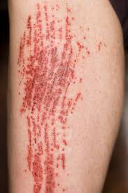

1. Blister
2. contusion
3. **abrasion**
4. sprain

8. Identify the injury

1. Blister
2. **contusion**
3. abrasion
4. tear

9. Identify the injury 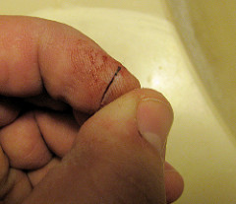

1. Blister
2. **laceration**
3. abrasion
4. tear

10. Identify the injury 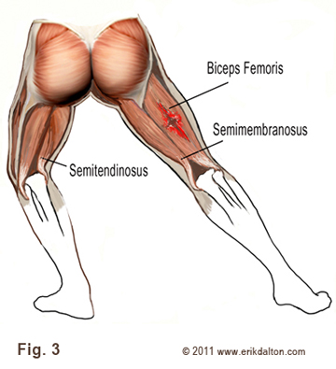

1. sprain
2. laceration
3. abrasion
4. **strain**

## Hard tissue injuries

1. define hard tissues

1. bones, teeth and ligaments
2. bones, ligaments and tendons
3. **bones and teeth**
4. muscles, tendons, t-tubules

2. How do you treat a fracture?

1. **immobilise the area**
2. immobilise the person
3. put ice on it
4. RICER

3. Another name for a dislocation is a

1. **Luxation**
2. Laxation
3. Sublaxation
4. Subluxation

4. Classify the fracture in the image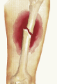

1. Open
2. **Closed**
3. Complicated
4. Greenstick

5. Classify the fracture in the image 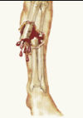

1. **Open**
2. Closed
3. Complicated
4. Greenstick

6. Classify the fracture in the image 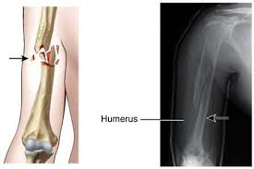

1. Open
2. Closed
3. **Complicated**
4. Greenstick

7. What type of fracture is in the image? 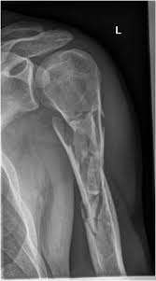

1. **Comminuted**
2. Complete
3. Incomplete
4. Greenstick

8. What type of fracture is in the image? 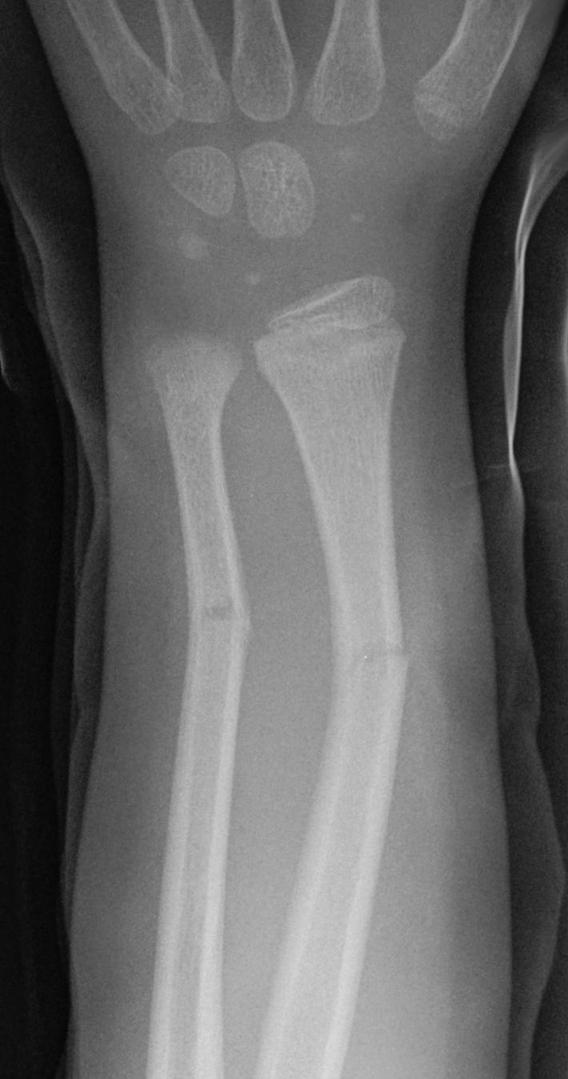

1. Comminuted
2. Complete
3. **Incomplete**
4. **Greenstick**

9. What type of fracture is in the image?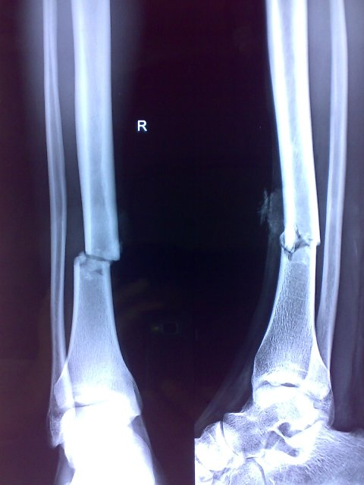

1. Comminuted
2. **Complete**
3. Incomplete
4. Greenstick

10. What type of injury is this?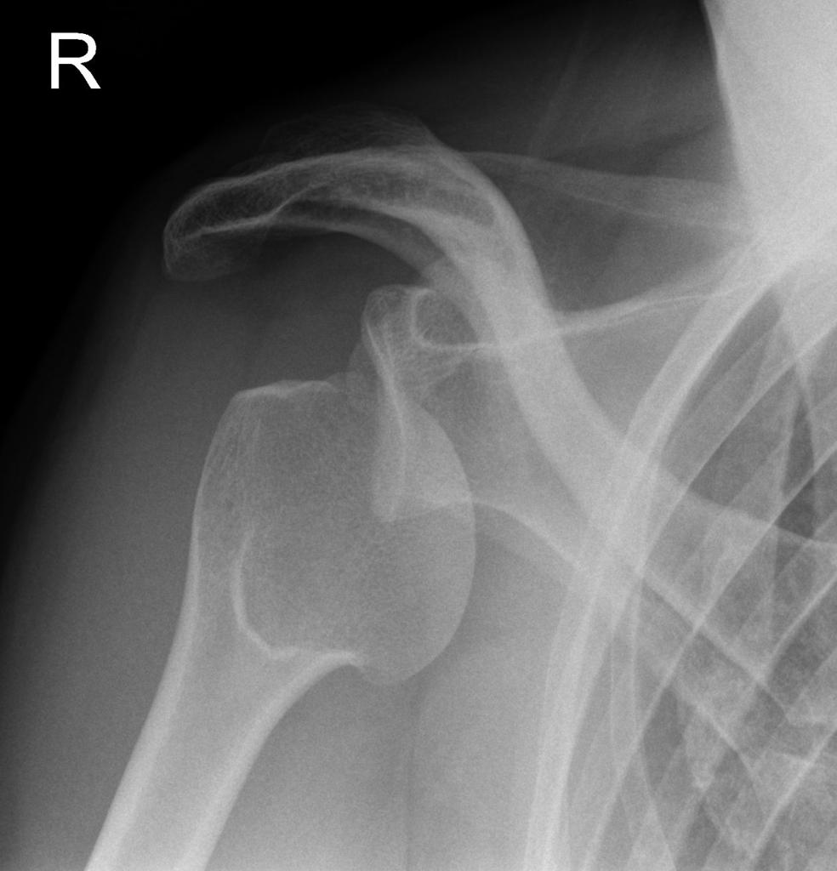

1. **dislocation**
2. fracture
3. sprain
4. strain

## Assessment of injuries

1. What does the first T in TOTAPS stand for?

1. Touch
2. Tickle
3. **Talk**
4. Toe

2. What does Active movement mean?

1. the assessor moves the injured area
2. someone else moves their leg
3. doing a skills test
4. **the athlete moves the injured area**

3. Where does DRSABCD fit with TOTAPS for a sprained ankle?

1. TOTAPS then DRSABCD
2. **DR then TOTAPS**
3. DRSABCD then TOTAPS
4. TO DR TAPS ABCD

4. What are you asking during Talk in TOTAPS?

1. What's your number? Do you want to go to dinner with me?  What's your name?
2. where are you from? how old are you?
3. **Where does it hurt? Did you hear anything? What happened?**
4. Where does it hurt? What happened? Can I touch you?

5. When would you stop TOTAPS to treat the injury?

1. **When it is clear the athlete cannot continue to play**
2. If they complete TOTAPS and are pain free
3. When you think the athlete can continue to play?
4. When it is clear the athlete is faking it

6. When would you stop TOTAPS to let the athlete continue to play?

1. When it is clear the athlete cannot continue to play
2. **If they complete TOTAPS and are pain free**
3. When you think the athlete can continue to play?
4. When you think the athlete is faking it

7. A Skilles test should...

1. progress from general whole body to joint specific movements
2. test the athlete's ability to run
3. test the athlete's ability to catch
4. **progress in intensity and sports specificity**

8. What are you looking for when Observing the injured area?

1. **swelling, redness, & malformation**
2. swelling, redness, tenderness, & heat
3. heat, redness, & malformation
4. Tenderness, heat, & swelling

9. Would you let this athlete continue to play?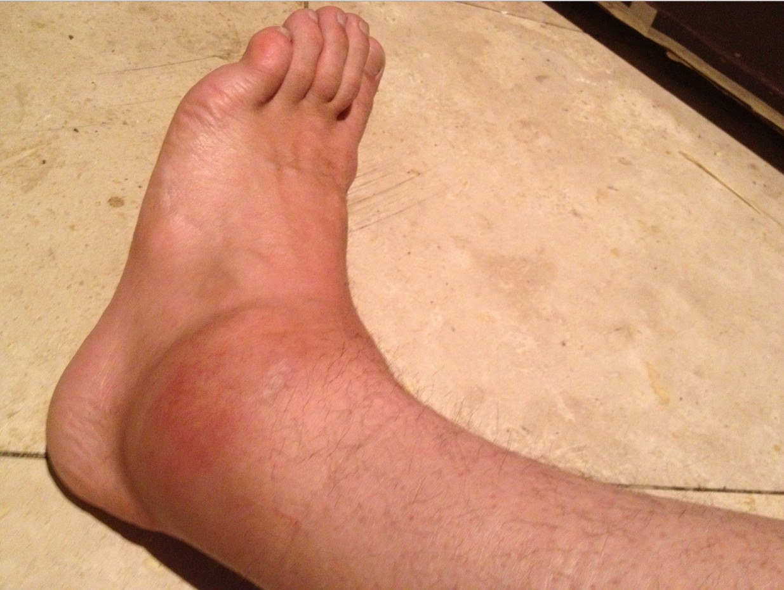

1. yes
2. **No**

10. What is the first thing you would do when an athlete on a netball court gets injured?

1. ask her what happened?
2. check her pulse
3. **check for danger to yourself**
4. talk to her about the injury